Ecuador 2011 – Spring Break for Hillel at Texas A&M University
Mindy Prengler, Program Director – March 2011

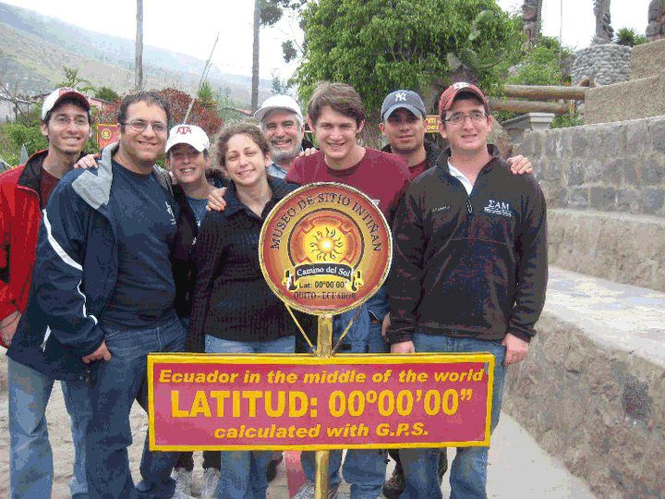

Students from the Texas A&M Hillel Foundation, led by Rabbi Peter E, Tarlow and Program director Mindy Prengler, experienced the ultimate Spring Break in Quito, Ecuador. With many thanks to the Albert and Ethel Herzstein Charitable Foundation, the Zale Foundation, and our Hillel family, including many alumni donations, we were able to make this cultural experience possible.

The students started off their travels with a layover in Panama, in which they got to explore the new and old city and the Akko Mountains. Later that night they arrived in Quito, Ecuador and got to meet the rector of Universidad de Cinencias Turistícas, Enrique Camarilla, and join his family for a traditional Ecuadorian meal. The students had a great time getting to know the Cabanilla’s and their culture. Their home became a home away from home for us.

The next day, Rabbi Tarlow taught the students a class about Jewish Latin America and about Crypto-Jewish life. Students toured UCT and interacted with the Ecuadorian students about the cultural differences between Ecuador and the United States. TAMU Hillel students shared with their Ecuadorian counterparts aspects about our Jewish culture and the Ecuadorian students shared with us their traditional customs. During this incredible experience, students had the opportunity of getting to know the UCT students and developed cross-cultural friendships. Students learned about the Ecuadorian importance of family, hospitality, friendship, cuisine, and even learned how to salsa dance!

The next days of the trip were spent touring the old city museums and the historical museums of Quito. Our TAMU Hillel students toured Quito’s different religious institutions and learned about the Baroque art history. Hillel students also had the chance to visit the Equator and experienced being in two hemispheres at once! Graham Schlanger, a senior, mechanical engineering major exclaims, “It was a phenomenal trip with a good mix of cultural learning and fun!”

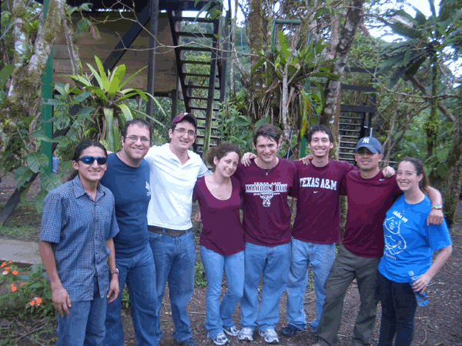
Following the days of touring, The Aggie Hillel explored the jungle terrain by going zip lining in Mindo. “The whole trip was incredible! It’s hard to pick out a single day that was my favorite, but zip lining was a real bonding experience for us, and seeing the Jewish life in Ecuador was an experience I’ll never forget,” senior, Michael Kleinfield, stated. Students experienced an Ecuadorian Shabbat Service at the Comunidad Judia del Ecuador synagogue. Hillel students interacted with the Jewish community and admired the beauty of the synagogue. Scott Lefton, vice prime minister of Hillel, states “It was really neat spending time with the Jewish community in Quito. I learned that even across vast geographical and cultural differences, we are remarkably similar.” As well as further exploring Judaism, students learned the value of nature through sightseeing and hiking the beautiful Ecuadorian mountains.

This ultimate spring break taught students a mixture of adventure, the beauty of culture, the history of Jewish Latin America, and the value of education. Ben Pisik, sophomore at Texas A&M remarks, “This truly was a learning experience for me. It increased my love of travel. It is absolutely beautiful in Ecuador. The culture is fascinating, and I am very grateful for the opportunity to have gone on this trip and the strong friendships I’ve made.”

The closeness of the Texas A&M Hillel is a quality that makes TAMU Hillel unique. This trip further enhances what it means to be part of our Aggie Hillel Family. As a group, we bonded, looked out for one another, and grew as individuals and as students. All of our students were very thankful to have experienced such a wonderful trip!

To learn more about Texas A&M Hillel please contact us at Hillel@tamuhillel.org or find us at the web at www.tamuhillel.org where you can see numerous photos regarding TAMU Hillel including our journeys to Ecuador and Peru.

